

YEAR: 9
SUBJECT: SCIENCE

TEST: Matter
TIME: 50 mins
QUESTIONS: Part A: Multiple Choice Questions (10 marks)
Part B: Short Answer Questions (28 marks)
Part C: Extended Response (5 marks)

TOTAL MARKS: 43 marks

DO NOT WRITE ON OR MARK THIS PAPER

SECTION ONE: Multiple Choice Questions (1 mark each)
Answer this section on the separate multiple – choice answer sheet

- Which of the following statements about atoms is true?
- Neutrons and protons are found in the nucleus with the electrons
- The number of neutrons found in the nucleus of an atom is always the same
- Protons circle the nucleus all the time
- An atom is mostly empty space

- The nucleus of an atom is made up of
- electrons and protons
- protons and neutrons
- neutrons and electrons
- neutrons

- An ion is best defined as: An atom which has

- lost electrons
- gained electrons
- gained or lost electrons
- gained neutrons

- The atomic symbol for a gold atom is 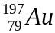. Clarify what this tells you about the gold atom.

- It contains 118 protons.
- It contains a total of 197 protons, neutrons and electrons.
- It contains 118 neutrons.
- It contains 197 electrons.

- What is the electronic configuration of a chlorine atom? Hint: Chlorine has an atomic number of 17.
- 2,2,2,2,2,2,2,2,1
- 2,8,7
- 8, 8, 1
- 2,10,5

- A phosphorus atom has an atomic number of 15. State how many electrons it has in its third (outermost) shell.

- 0
- 2
- 5
- 8

7. A radionuclide is:

- a radioactive isotope.
- a charged atom
- an element that emits beta radiation.
- an atom with the same number of protons but a different number of neutrons.

- The mass number of an atom is the number of

- neutrons in its nucleus.
- electrons in the nucleus.
- protons in the nucleus.
- protons plus neutrons in the nucleus.

- Which of the following will cause an atom to become a negative ion?
- gain electrons.
- lose protons.
- gain neutrons.
- lose neutrons.

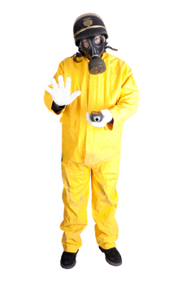
- Scientists use the process of decay in radioactive isotopes called to determine the of organisms.

- aging; carbon
- radioactive aging; carbon
- dating; age
- carbon dating; age


SEMESTER ONE 2018
Chemistry Test:
ANSWER BOOKLET
NAME:
FORM: DATE:

Multiple Choice Short Answer Extended Response Total

/10

/28

/43

/5

SECTION ONE: Multiple choice answers
Cross (X) through the correct answer.

1 | a | b | c | d
2 | a | b | c | d
3 | a | b | c | d
4 | a | b | c | d
5 | a | b | c | d
6 | a | b | c | d
7 | a | b | c | d
8 | a | b | c | d
9 | a | b | c | d
10 | a | b | c | d

SECTION TWO: Short Answer (28 marks)
Answer the questions in the spaces provided.

Question 11

Identify the number of protons, neutrons and electrons in the atom of potassium: (3 marks)
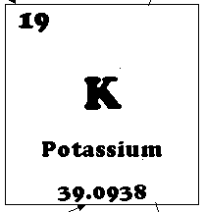

- protons:
- neutrons:
- electrons:

Question 12
For each of the electron configurations below, construct an electron diagram and write the name of the element you have drawn. (8 marks)

Electron Configuration: 2, 8, 1 Electron Configuration: 2, 7
Element: ______________ Element: ________________

Electron Configuration: 2, 8, 6 Electron Configuration: 2, 8
Element: ________________ Element: _______________

Question 13
Carbon has different isotopes, as shown in the diagram below.
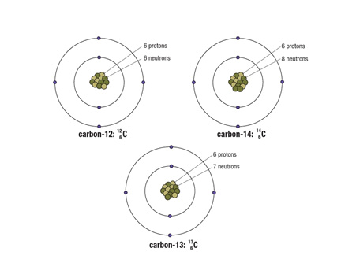
Describe the similarities and differences between these shown. (3 marks)

__ __ __ _________ _____________________________________________________________________________________________________________________________________________________________

Question 14
Compare and contrast alpha, beta and gamma decay of radionuclides. (4 marks)

TYPE OF DECAY | COMPARE | CONTRAST
ALPHA
BETA
GAMMA

Question 15
The atoms below are written using the letters V to Z instead of their correct chemical symbols.
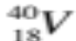 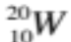 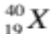 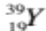 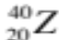 (4 marks)
- Which two atoms have the same number of neutrons?
______________________________________________________________________________
- Which atom has the smallest mass number?
______________________________________________________________________________
c) Which two atoms belong to the same element?
______________________________________________________________________________
- Which atom has the electron configuration 2, 8?
_____________________________________________________________________________
Question 16
This paragraph has some missing words. Their positions are numbered. (6 marks)
Ernest (1) proposed a new model for the atom where there is a small positively-charged (2) surrounded by (3) -charged electrons. Later on scientists discovered that there were two types of particles inside the nucleus—positively-charged (4) and neutrons, with no (5) . The number of protons is always the same as the number of (6) .

Which word goes in which position? Choose the correct word from the jumbled list below by writing each one in the correct numbered position:

charge electrons negatively nucleus protons Rutherford

(1) ____________________
(2) ____________________
(3) ____________________
(4) ____________________
(5) ____________________
(6) ____________________

SECTION THREE: Extended Response (5 marks)
Select ONE of the following questions and write the question number in the box below. Answer the question in the space provided.
- Explain why oxygen atoms ionise to form the oxide ion with a charge of –2. Identify if oxide is an anion or a cation.
- Explain why radiation is dangerous for living cells but can be applied to treat people with some forms of cancer.

Question Number:

END OF TEST
Please check your work!

